DQL 7

- Produce the following output

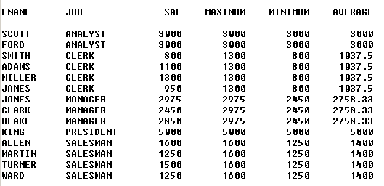

- Produce the following output

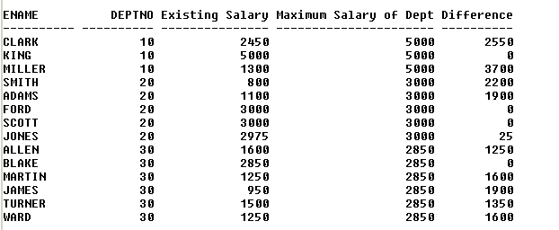

- Display only the second highest salary employee (s) record (s) in each job type

- Display the record (s) of employee (s) having the oldest hiring date in their respective job type

- Display the highest earner (s) records in each deptno

